**Don’t waste   
your waste!**

24   
Interest free installments

Transform it into growth:

Create your own Bio-Fertilizer!

**HomeBiogas is a disruptive technology that transforms organic waste into rich Bio-Fertilizer and cooking gas while enabling you to:**



**resources and help save the planet**

**on daily cooking gas**

**on chemical fertilizer**

**We are the generation of regeneration!**Join thousands of others who upcycle organic waste to create their own supply of Bio-Fertilizer and renewable energy.

**Option 2:   
Don’t just recycle - UPCYCLE!**Join thousands of others around the world who are choosing regenerative agriculture – for the plant, for the environment, for your pocket.

**Transforming waste into growth //   
Good for the plants. Good for the planet. Good for your pocket.**

* Transform your waste into a resource
* Use less chemical fertilizer
* Produce Bio-Fertilizer for better plant growth
* Decrease pesticide and fungicide use
* Produce up to 6 hours of cooking gas daily
* Integrates into existing irrigation systems
* Complete ROI after one year

Healthier soil >> Healthier plants >> **INCREASED YIELDS**

**Easy to install and get started**

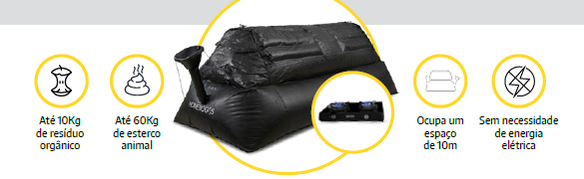

Input 10K of organic waste

Requires 10m2 of space

Requires 10m2 of space

Input 60K of animal manure